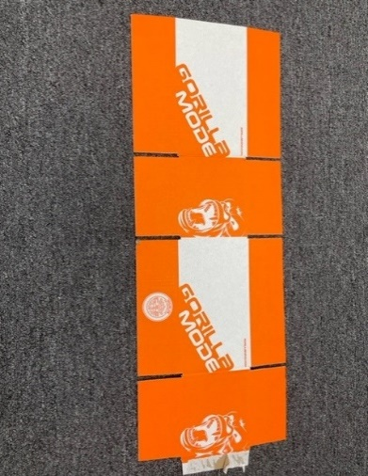

The most common and easily recognizable of all boxes is the RSC or Regular Slotted Carton. This very versatile and inexpensive carton is perfect for use as a shipping box.

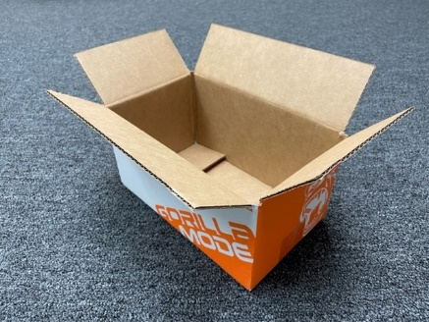

***RSC***

*Regular Slotted Carton*

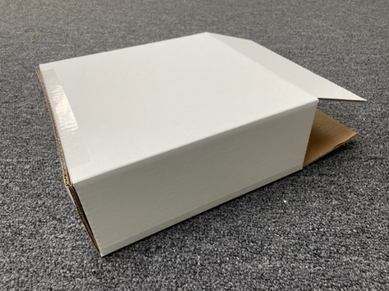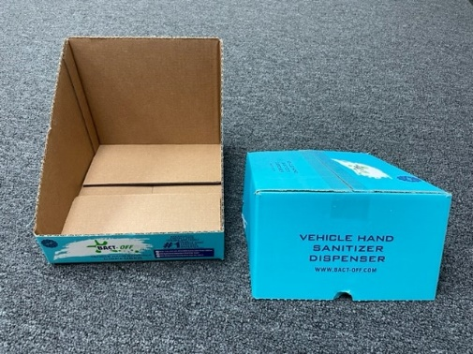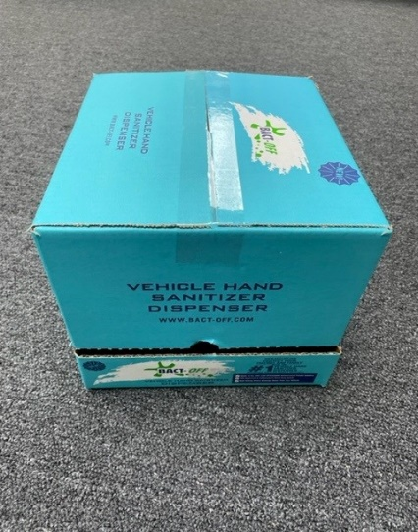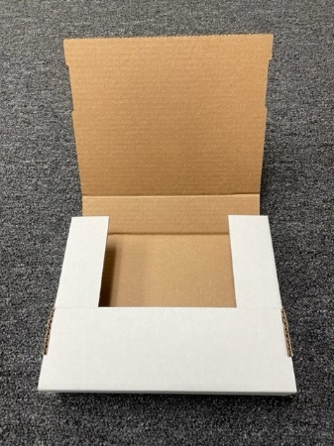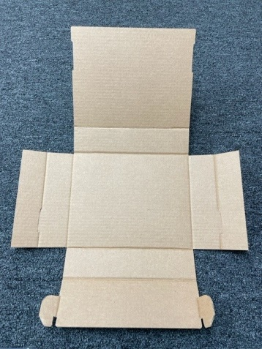

A Full Overlap Carton (FOL) refers to the fact the outside/major flaps overlap completely to form an extra layer of protection at the ends of the carton. This style of carton lends itself to heavy contents and/or narrow cartons.

***FOL***

*Full Overlap Carton*

A Retail Ready RSC is designed to be a shipping container which has perforations so that it is possible for a retailer to tear off the top of the box to display product.

***RETAIL READY RSC***

***BOOKFOLD***

As the name suggests, Bookfolds are often used for shipping books and other types of literature. While this style of shipper may be useful for other items, its ideal cargo is less than 1 ½” thick.

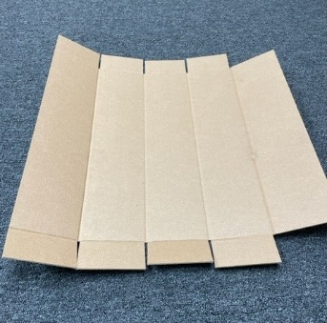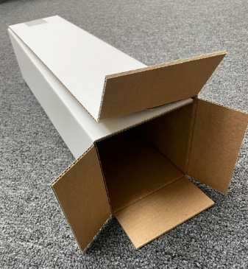

A Five Panel Folder is similar to an RSC without having a glue joint. It is constructed to wrap around a product and be secured with tape in the long dimension and at the ends.

***5 PANEL FOLDER***

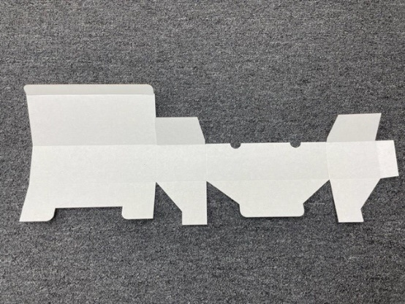

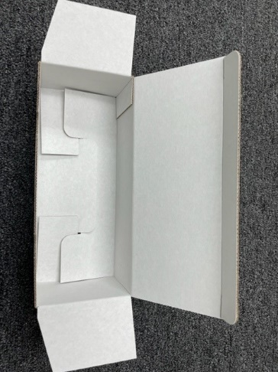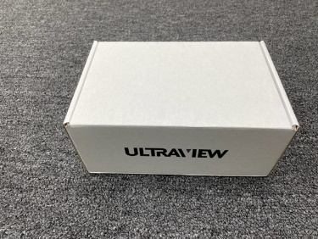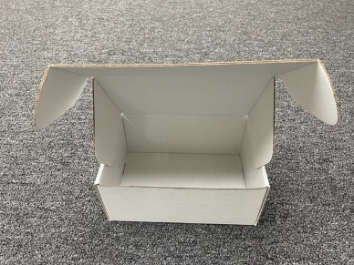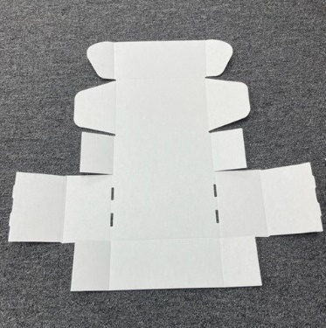

Another style of glued carton, a Snap Lock Bottom Tuck Top has bottom flaps which interlock and a top flap which tucks in to close the box. This style of carton is not generally used as a shipper but is instead a retail product box or a gift box which may arrive inside an outer carton or master box.

***SNAP LOCK BOTTOM***

***TUCK TOP CARTON***

A Regular Front Lock Mailer is a non-glued carton which has two side rollovers, top flaps or ears which tuck into the front of the box, and may or may not also have side dust flaps. Side dust flaps tuck to the inside of the box and make this mailer pilfer proof. This mailer style is the most commonly used E-Commerce box.

***FRONT LOCK MAILER or***

***RELF – Roll End Lock Front Mailer***

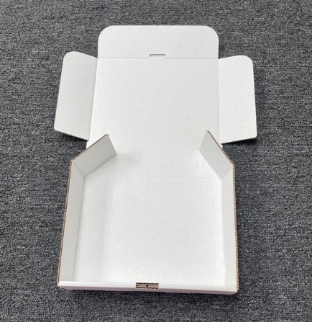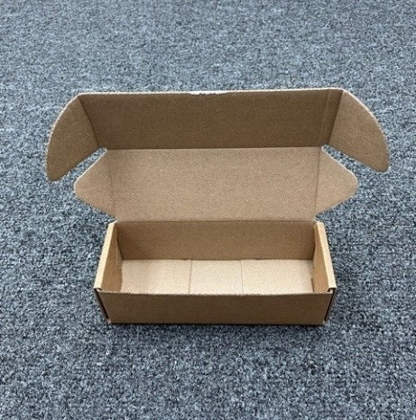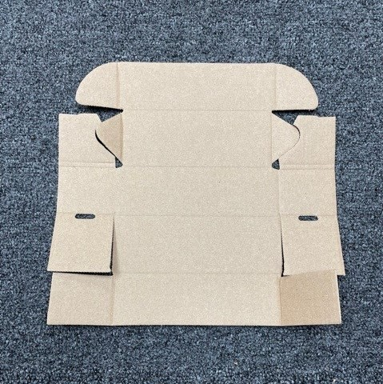

A Pizza Style Box is just one of several less common unglued cartons. It has one roll over in the front and three flaps which tuck to the inside of the box. While a little more difficult to load with product, this style of box is generally a board saver design and so is less expensive than other designs to produce.

***FRONT ROLL OVER or***

***PIZZA STYLE BOX***

An Indestructo Mailer is another form of an unglued front lock mailer. It folds up differently than a regular front lock mailer but looks the same once it is formed. Its main attraction is that it is a board saving design (think cost savings) whenever the width of the box is close to the same dimension as the depth of the box. This mailer size is also commonly used for E-Commerce applications.

***INDESTRUCTO MAILER***